CMPS 350 Project Phase 1 – Report
Education Platform
(10% of the course grade)
The report must be submitted in Word format only
Group Members | Student1 full name (StudentId)  Student2 full name (StudentId)  Student3 full name (StudentId)  Emails: student1@student.qu.edu.qa; student2@student.qu.edu.qa; student3@student.qu.edu.qa;
GitHub link | Give a public link to you code (It is not acceptable to send codes by email)

Grades :
The student fills only the “Implementation Percentage”: Please specify either: Working (completed x%), Not Working (completed x%) or Not done.
Criteria | Points | Implementation Percentage | Implementation Quality | Your Grade
Design and implement the app Web UI and navigation using HTML, CSS and JavaScript. Including designing the App Web UI and navigation. | 50
Design and implement the Web API and data access repositories to read/write the app data JSON files. | 30
Application modeling (e.g. UML diagrams) to explain the data entities and the functionalities | 5
Testing documentation using screen shots illustrating the testing results. | 5
Team work quality. Contributions of team members - All members should collaborate and contribute equally to the project. | 5
Project report – description of the implemented app, what is implemented, what is missed .. | 5
Total | 100
Plagiarism, outsourcing, free riders | -100
Delivery behind the deadline | -5

Important remark: In case of copying and/or plagiarism or not being able to explain or answer questions about the implementation, you lose the whole grade.
* Criteria for grading the functionality:
- The functionality is working: you get 70% of the assigned grade.
- The functionality is not working: you lose 40% of assigned grade.
- The functionality is not implemented: you get 0.
- The remaining grade in all cases from above is assigned to the quality of the implementation,
- The grades are distributed on the various use cases, when the design/implementation is partial, you get only the grades of designed/implemented use cases.

Code quality criteria, include:
- Use of meaningful identifiers for variables and functions (e.g. using JavaScript naming conventions)
- Pages are responsive
- Clean code: simple and concise code, no redundancy
- Clean implementation without unnecessary files/code
- Use of comments where necessary
- Proper code formatting and indentation.

You lose marks for code duplication, poor/inefficient coding practices, poor naming of identifiers, unclean/untidy submission, and unnecessary complex/poor user interface design.

Important Remark:
[Grades: 100-85]: Will be given only to fully functional application with all the quality criteria cited above met and the project has excellent design for the various functionalities. The report is professional.
[Grades: 85-80]: Will be given only to functional application with most of all the quality criteria cited above met and the project has good design for the various functionalities. The report is professional.
[Grades: 80-75]: 80% of the application functionalities are functional. The project respects partially the quality criteria. The report is professional but misses some information.
The grades are not negotiable. We expect that only a small portion (around 15%) of the class will be able to meet the criteria for the grades [100-85]. You should work hard to and demonstrate the merits of your application to earn those grades.+

Description of your proposed platform

Give an overview of how your application works

Application Design

Use case diagram

Entities class diagram
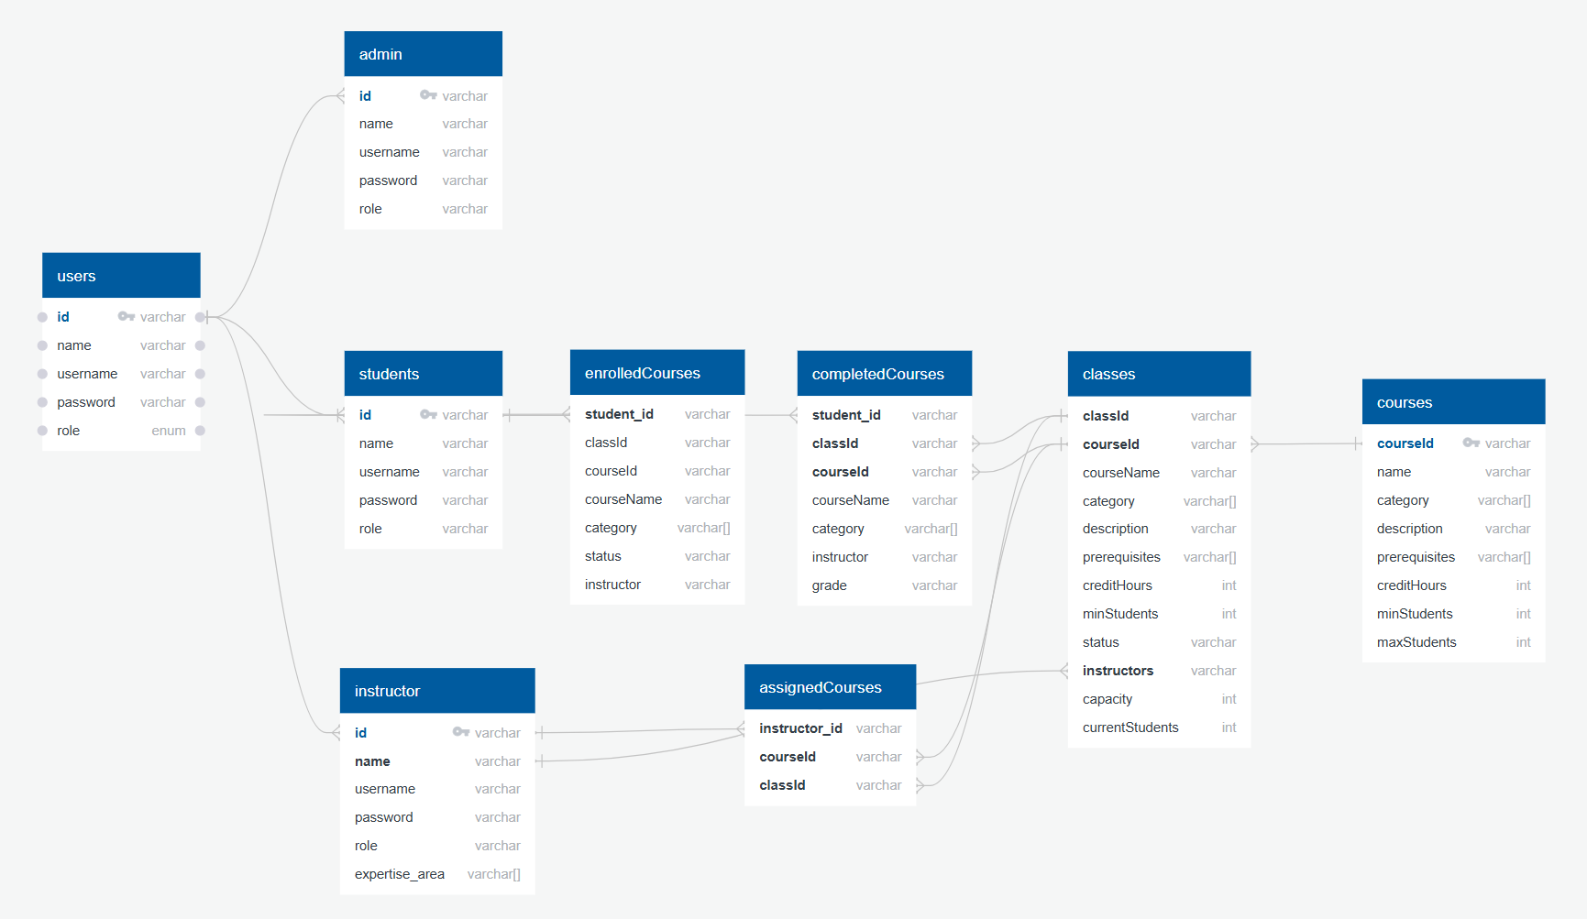

Describe your data as a class diagram or Entity Association diagram

Web API class
List all the methods (functions) to query your data entities

Implementation

Implemented use-cases

Unimplemented use-cases and not functioning parts

Testing

Use case 1

Use case 2

Use case 3

Use case 4

Use case 5

Discussion of the project contribution of each team member

Student name | Student contributions

